IMPORTANT NOTE: This information is not to be released or distributed until 10 a.m. Central Time on October 14, 2015. A photo to accompany this story appears on page 2; please provide credit for this photo, which is listed below the image.

Arkansas & Red River Basins Receive a C- in
New Mississippi River Watershed Report Card

The newly released Report Card produced by America’s Watershed Initiative (AWI) includes specific information and grades for the five main river basins that make up the 31-state Mississippi River Watershed, including the Arkansas and Red river basins. In the Report Card, five goals for the Arkansas and Red are measured—water supply, flood control and risk reduction, the economy, ecosystems, recreation and transportation. Overall, the Arkansas and Red river basins received an average grade of “C-” for these six goals.

The Arkansas River Basin originates in the Rocky Mountains and empties into the Lower Mississippi River, covering a total length of 1,469 miles. It is the second longest tributary of the Mississippi River watershed and is highly valued for its recreational uses including swimming, boating, fishing and hunting. Navigation on the lower portion of the river is maintained by a series of 18 locks and dams, which also enhance recreation, produce hydroelectric power and provide flood control. The Red River Basin forms most of the Texas-Oklahoma border before emptying into the Mississippi River in Louisiana. Much of the management of the river, according to the Red River Compact, is based on the appropriation of water to agriculture, municipalities, industry, hydroelectric power and recreational uses while balancing ecosystem health needs.

Although wetland areas increased, lock delays in 2013 were higher than at any other time from 2000 through 2012. Infrastructure condition and maintenance were very poor. Levee condition was also poor, and over 4 percent of communities had water supply treatment violations.

The Arkansas and Red River Basin also faces additional challenges in water stress associated with potential transfers of water resources outside of the basin. A substantial portion of the basin is west of the 100th meridian that marks a shift in precipitation, with wetter conditions to the east of the 100th meridian. The very poor result for lock delays, combined with the very poor infrastructure condition and maintenance, are especially troubling considering that these locks and dams are newer than many other sections of the system having been completed in the early 1970s.

The complete analysis for the Arkansas and Red river basins in the Report Card—along with information about the other four basins that make up America’s Watershed—is available online at AmericasWatershed.org/ReportCard.

###

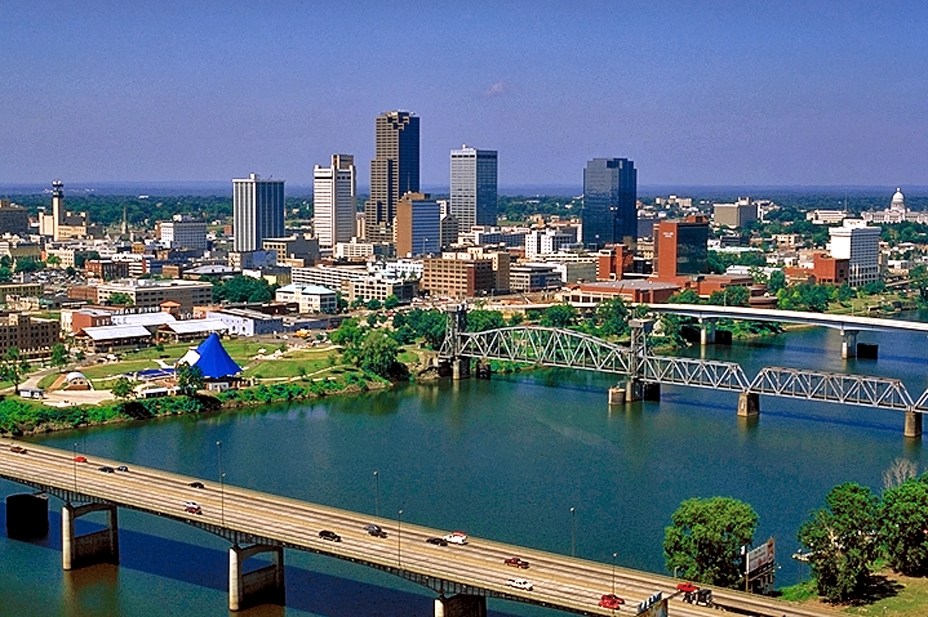
Little Rock skyline on the Arkansas River. Credit Arkansas Parks and Tourism

