IMPORTANT NOTE: This information is not to be released or distributed until 10 a.m. Central Time on October 14, 2015. A photo to accompany this story appears on page 2; please provide credit for this photo, which is listed below the image.

Coastal Wetlands Receive a D Grade in the
New Mississippi River Watershed Report Card

The newly released Report Card produced by America’s Watershed Initiative (AWI) includes key information about coastal wetlands in the Mississippi River Delta. Overall, coastal wetlands received a D grade in the Report Card.

Coastal wetlands in Louisiana at the delta of the Mississippi River are rich in plants and animals, provide critical storm protection for coastal communities, are the nursery for the commercial seafood industry and are a culturally unique area with hundreds of years of rich history. At the southern point on the Mississippi River flyway, these coastal wetlands provide wintering habitat for millions of ducks and waterfowl and critical habitat for other species on their seasonal journeys each year. Louisiana’s wetlands extend as far as 80 miles (130 km) inland and along the coast for about 185 miles (300 km). Louisiana's wetlands today represent about 40 percent of the wetlands of the continental United States, but about 80 percent of the nation’s wetland losses. According to the U.S. Geological Survey, about 75 square kilometers of Louisiana's 3 million acres of wetlands are lost annually, and reducing these losses is challenging and costly.

However, not all the wetlands are receding; in fact some wetlands are stable, and others are actually growing. Inputs of sediment allow existing coastal wetlands to maintain elevation relative to sea level rise and create new wetland area to balance losses from erosion. Construction of reservoirs along the Mississippi River and its tributaries during the 20th century has reduced the amount of sediment carried by the river from historical amounts. Channelizing the river and constructing levees to control flooding along the Lower Mississippi River drastically reduces the amount of the remaining sediment that is delivered to coastal wetlands. Most of the sediment carried to the Gulf of Mexico through the Lower Mississippi River is washed out through the river mouth in the Bird’s-foot Delta and deposited in deep water, where it is no longer available to nourish coastal wetlands. This situation follows engineering efforts to maintain high water velocities through the shipping canal.

The complete analysis for coastal wetlands in the Report Card—along with information about the hypoxic or “dead” zone in the Gulf of Mexico—is available online at AmericasWatershed.org/ReportCard. The online information includes grades for each of the five sub-basins within the Mississippi River Watershed as well as six goals measured in the Report Card: the economy, ecosystem health, water supply, transportation, recreation and flood control and risk reduction. The online Report Card also includes for each goal information concerning what was measured and how it was evaluated.

###

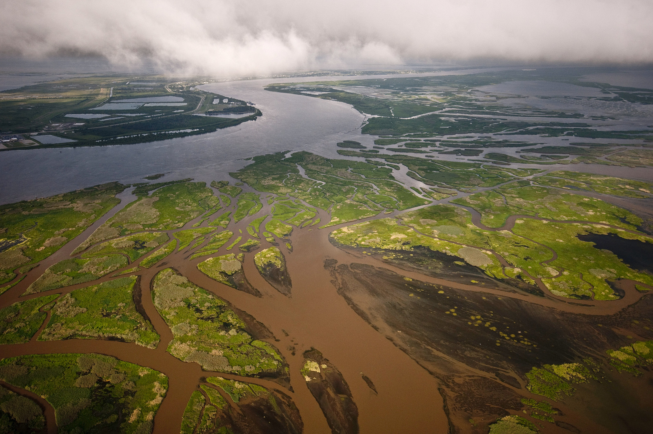
Mississippi River Delta. Credit Bridget Besaw

