IMPORTANT NOTE: This information is not to be released or distributed until 10 a.m. Central Time on October 14, 2015. A photo to accompany this story appears on page 2; please provide credit for this photo, which is listed below the image.

The Economy Receives Average Grades in the
New Mississippi River Watershed Report Card

The newly released Report Card produced by America’s Watershed Initiative (AWI) includes key information about the economy in the 31-state Mississippi Watershed. The AWI goal for the economy is that the Mississippi River Watershed, or America’s Watershed, supports local, state and national economies, to include agricultural, industrial and energy production uses.

Access to high-quality water in sufficient, reliable quantities is critical for many economic sectors in local, state and national economies. Many businesses rely on water supply for operations and production of goods. The Mississippi River Watershed’s resources are used in power generation, agricultural irrigation, animal husbandry and industrial production. The total amount of water available for use is limited, and allocation decisions become increasingly difficult as demand increases and supplies become less reliable. Diminished water quality adds to this difficulty. Planning for the efficient use of water among a diversity of stakeholders is critical to sustaining the basin’s economies. Along with supporting local economies, the Mississippi River Watershed supports economic development across the nation through the export of water for such things as crops, meat, textiles, bottled water and beverages. As water stresses increase nationally, greater pressures will be placed on local water resources, with potentially harmful effects to the economy of the Watershed.

The grades for the economy in the overall Watershed and the five basins reflect general economic conditions nationwide, differing only slightly among the basins. Additional data is needed to better reflect how local economies directly tie to the management of the Watershed and its rivers. Such data will be included in future Report Cards. The Upper Mississippi River Basin received a grade of C+ for the economy goal. The Ohio and Tennessee, the Lower Mississippi, and the Arkansas and Red river basins each received grades of C. And the Missouri River Basin received a grade of C-.

The complete analysis for the economy in the Report Card—along with information about the other five goals for America’s Watershed—is available online at AmericasWatershed.org/ReportCard. The online information about the economy includes what was measured and how it was evaluated.

###

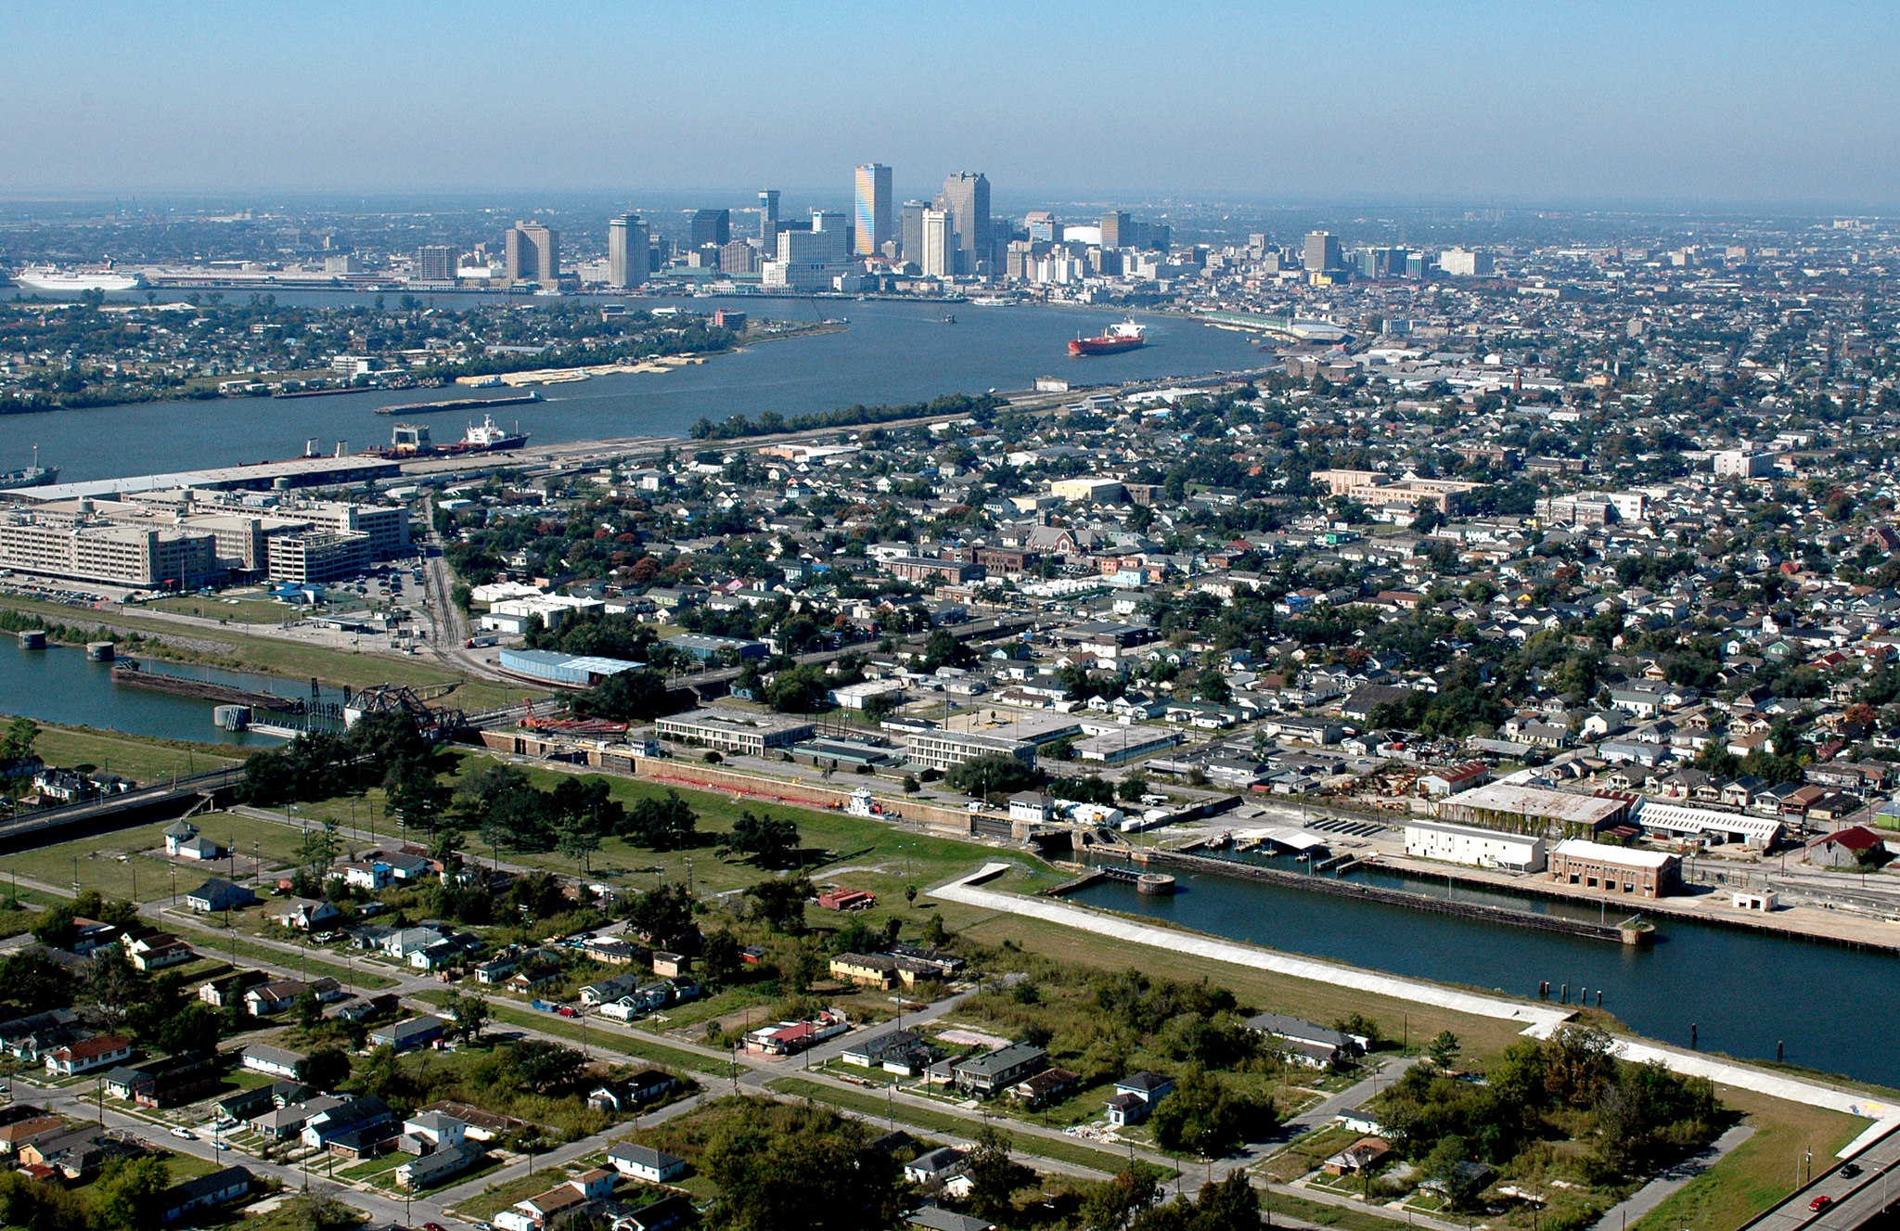
Credit USACE

