IMPORTANT NOTE: This information is not to be released or distributed until 10 a.m. Central Time on October 14, 2015. A photo to accompany this story appears on page 2; please provide credit for this photo, which is listed below the image.

Ecosystems Receive a C Grade in New
Mississippi River Watershed Report Card

The newly released Report Card produced by America’s Watershed Initiative (AWI) includes key information about the ecosystems in the 31-state Mississippi Watershed. The AWI goal for the Mississippi River Watershed, or America’s Watershed, is to conserve, enhance and restore ecosystems within the watershed to support natural habitats and the fish and wildlife resources that depend on them.

Healthy and productive ecosystems provide abundant fish, wildlife and vegetation, which in turn offer services and products to society, including clean water, flood risk reduction, food, recreation jobs, and income. Maintaining healthy ecosystems depends on natural processes that support natural habitats and abundant native fish and wildlife resources.

The watershed received a C grade for Ecosystems. The grades for Ecosystem varied more across the basins than for any other goal, with some basins showing very positive results while others face significant challenges. The industrialized eastern portion of the watershed and the Lower Mississippi River show the greatest threats to natural areas. Poor water quality is a result of high nutrient runoff from agriculture and industry and is a major cause of low oxygen in the waters of the northern Gulf of Mexico.

The complete analysis for ecosystems in the Report Card—along with information about the other five goals for America’s Watershed—is available online at AmericasWatershed.org/ReportCard. The online information about ecosystems includes grades for each of the five sub-basins within the Mississippi River Watershed as well as what was measured and how it was evaluated.

###

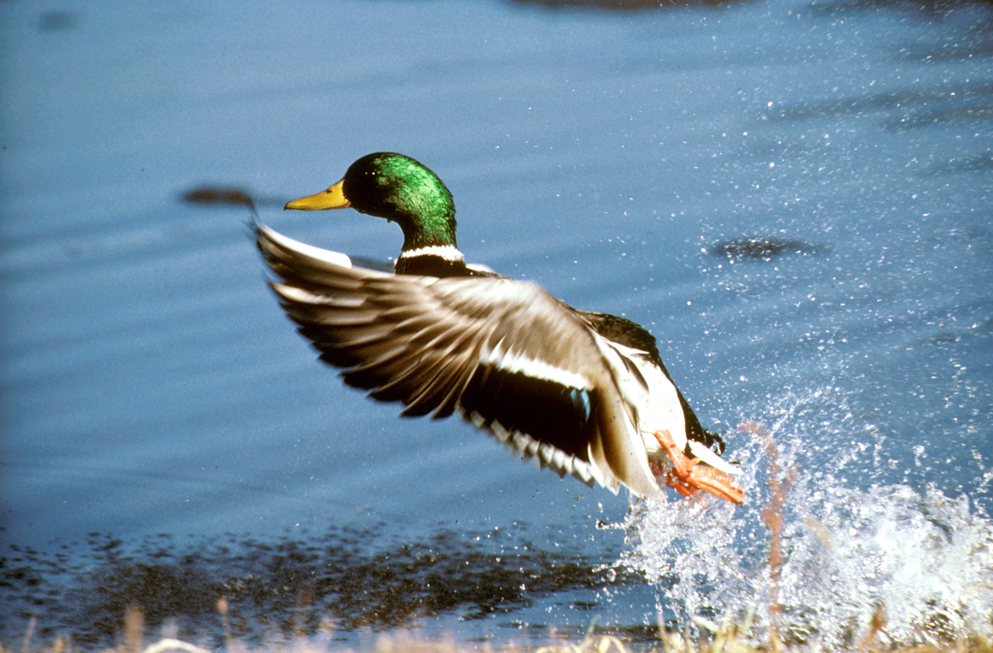
Credit NRCS

