IMPORTANT NOTE: This information is not to be released or distributed until 10 a.m. Central Time on October 14, 2015. A photo to accompany this story appears on page 2; please provide credit for this photo, which is listed below the image.

Flood Control Receives a D+ in New
Mississippi River Watershed Report Card

The newly released Report Card produced by America’s Watershed Initiative (AWI) includes key information about flood control and risk reduction in the 31-state Mississippi Watershed. The AWI goal for the Mississippi River Watershed, or America’s Watershed, is to provide reliable flood protection, including appropriate floodplain connections for water conveyance and ecosystem benefits, and to manage surface and storm water runoff to better protect life, property and economies.

The threats from floods can increase significantly when watersheds lose their natural capacity to store water, when communities and other permanent structures are developed in flood-prone areas, when there are changes in the landscape that cause increased surface water runoff, and when infrastructure—such as levees and dams originally built to manage flood risk—begin to age or are not maintained. The extent of flooding can often be reduced by a variety of strategies including reservoirs to reduce peak river flows; levees and flood walls to contain flood waters; and preserving wetlands to provide natural flood storage and to redirect flood waters. The chance of flooding can never be reduced to zero. The challenge for flood control and risk reduction in the future will be to maintain existing measures that have proven effective against damaging flooding—both structural and nonstructural—while at the same time finding new strategies that respond to a changing climate, rising sea level, coastal subsidence and erosion.

The watershed received a grade of D+ for flood control and risk reduction. The results in the Report Card were poor, especially because development within floodplains is increasing. Risks from severe river floods were highest in the eastern portion of the watershed and along the Lower Mississippi River, although intensive investment in flood control infrastructure avoided huge losses from the record flood in 2011.

The complete analysis for flood control and risk reduction in the Report Card—along with information about the other five goals for America’s Watershed—is available online at AmericasWatershed.org/ReportCard. The online information about flood control includes grades for each of the five sub-basins within the Mississippi River Watershed as well as what was measured and how it was evaluated.

###

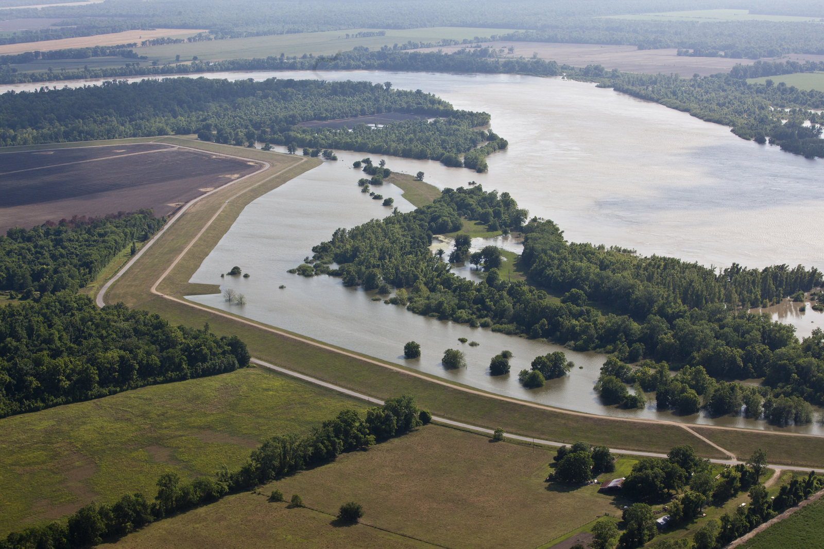
Credit David Y. Lee

