IMPORTANT NOTE: This information is not to be released or distributed until 10 a.m. Central Time on October 14, 2015. A photo to accompany this story appears on page 2; please provide credit for this photo, which is listed below the image.

Lower Mississippi River Basin Receives a D+ in
New Mississippi River Watershed Report Card

The newly released Report Card produced by America’s Watershed Initiative (AWI) includes specific information and grades for the five main river basins that make up the 31-state Mississippi River Watershed, including the Lower Mississippi River Basin. In the Report Card, five goals for the Lower Mississippi River Basin are measured—water supply, flood control and risk reduction, the economy, ecosystems, recreation and transportation. Overall, the Lower Mississippi River Basin received an average grade of “D+” for these six goals.

The Lower Mississippi River Basin is used extensively for transportation, made possible by a natural supply of abundant water from upstream and the comprehensive Mississippi River and Tributaries Project. This two-way transportation system—with its levees, floodways, channel improvements and tributary basins improvements—links the cities, factories and farms of the American heartland to world markets. The facilities along this stretch of river comprise the largest port system in the world in terms of tonnage moved. The coastal wetlands here support recreational activities, agriculture and a seafood industry valued at billions of dollars per year.

The basin had high marks for recreation from hunting and fishing license sales and relatively good streamside habitat. The low overall score is driven by poor condition of the communities of fish and organisms living in the river and stream bottoms, substantially lower median income, lock delays approaching the worst-performing year, poor infrastructure condition and maintenance, an increase in the number of people moving into the floodplain relative to overall population change, poor levee condition, low numbers of communities with building elevation requirements, and nearly 5 percent of water supply systems reporting treatment violations.

The Lower Mississippi River receives all of the water that flows down from the other basins as well as the riverine transportation of imports and exports that make up a large component of the national economy. The poor performance in lock delays and inland infrastructure condition and maintenance paints a challenging picture for future transportation system failures, with potentially devastating national economic consequences. At the bottom of the “funnel,” the basin also feels the effects of flooding that occur anywhere in the Mississippi River Watershed. The flood control and risk reduction issues that are reported in the scores represent relative risk; however, despite the low scores, the flood control system performed exceedingly well during the record floods of 2011, as no lives were lost and there was minimal property damages.

The critical wetlands in the Lower Mississippi River Basin continue to decline although increasing efforts to slow the loss—including water diversions and the beneficial use of materials dredged from the shipping channel to restore wetlands—are having a positive impact. Coastal waters in the Gulf of Mexico are also threatened by a large hypoxic zone that depletes oxygen from the water that forms annually as a result of excess nutrient runoff from the river.

The complete analysis for the Lower Mississippi River Basin in the Report Card—along with information about the other four basins that make up America’s Watershed—is available online at AmericasWatershed.org/ReportCard.

###
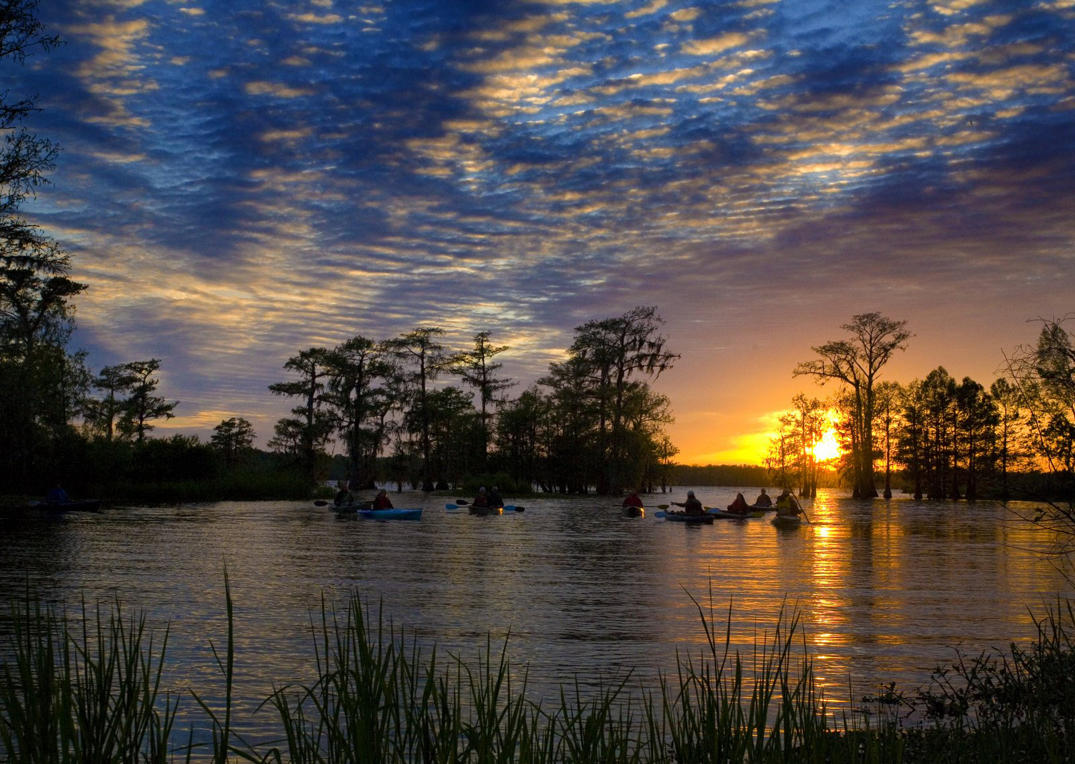
Credit U.S. Army Corps of Engineers

