IMPORTANT NOTE: This information is not to be released or distributed until 10 a.m. Central Time on October 14, 2015. A photo to accompany this story appears on page 2; please provide credit for this photo, which is listed below the image.

Missouri River Basin Receives a D+ in
New Mississippi River Watershed Report Card

The newly released Report Card produced by America’s Watershed Initiative (AWI) includes specific information and grades for the five main river basins that make up the 31-state Mississippi River Watershed, including the Missouri River Basin. In the Report Card, five goals for the Missouri River Basin are measured—water supply, flood control and risk reduction, the economy, ecosystems, recreation and transportation. Overall, the Missouri River Basin received an average grade of “C” for these six goals.

With its headwaters in the Rocky Mountains and flowing some 2,300 miles, the Missouri River Basin is the longest tributary on the Mississippi River. Its major tributaries include the Platte, Yellowstone, Kansas and James Rivers. Historically, the untamed Missouri River produced violent floods in the spring and summer, with erosion eating away its banks and muddying its waters. River flow is heavily impacted by low and extremely varied precipitation across the watershed. A series of levees and dikes support navigation in the lower section from the junction with the Mississippi River upstream to Sioux City, Iowa. The middle section includes six large dams that create the largest reservoir storage system in the world by volume and support flood control and risk management, navigation, fish and wildlife habitat, water supply, recreation and irrigation.

The Missouri River Basin overall C grade was much because of poor scores resulting from challenging issues in ecosystems and water supply. The Missouri scored well in the number of hunting and fishing licenses issued. It also has a higher number of communities with building elevation requirements for flood control preparedness. However, there were a high number of communities with water supply systems reporting treatment violations and water depletion was high. Because navigation in the Missouri Basin is not reliant on locks and dams, the report card for navigation only includes information about overall system maintenance.

The Missouri River Basin represents the largest area of the tributary watersheds and has a high percentage of its area in the drier western portion of the Mississippi River Watershed. Therefore, water allocation issues and issues related to flood control and flow management continue to be challenging in this region.

The complete analysis for the Missouri River Basin in the Report Card—along with information about the other four basins that make up America’s Watershed—is available online at AmericasWatershed.org/ReportCard.

###

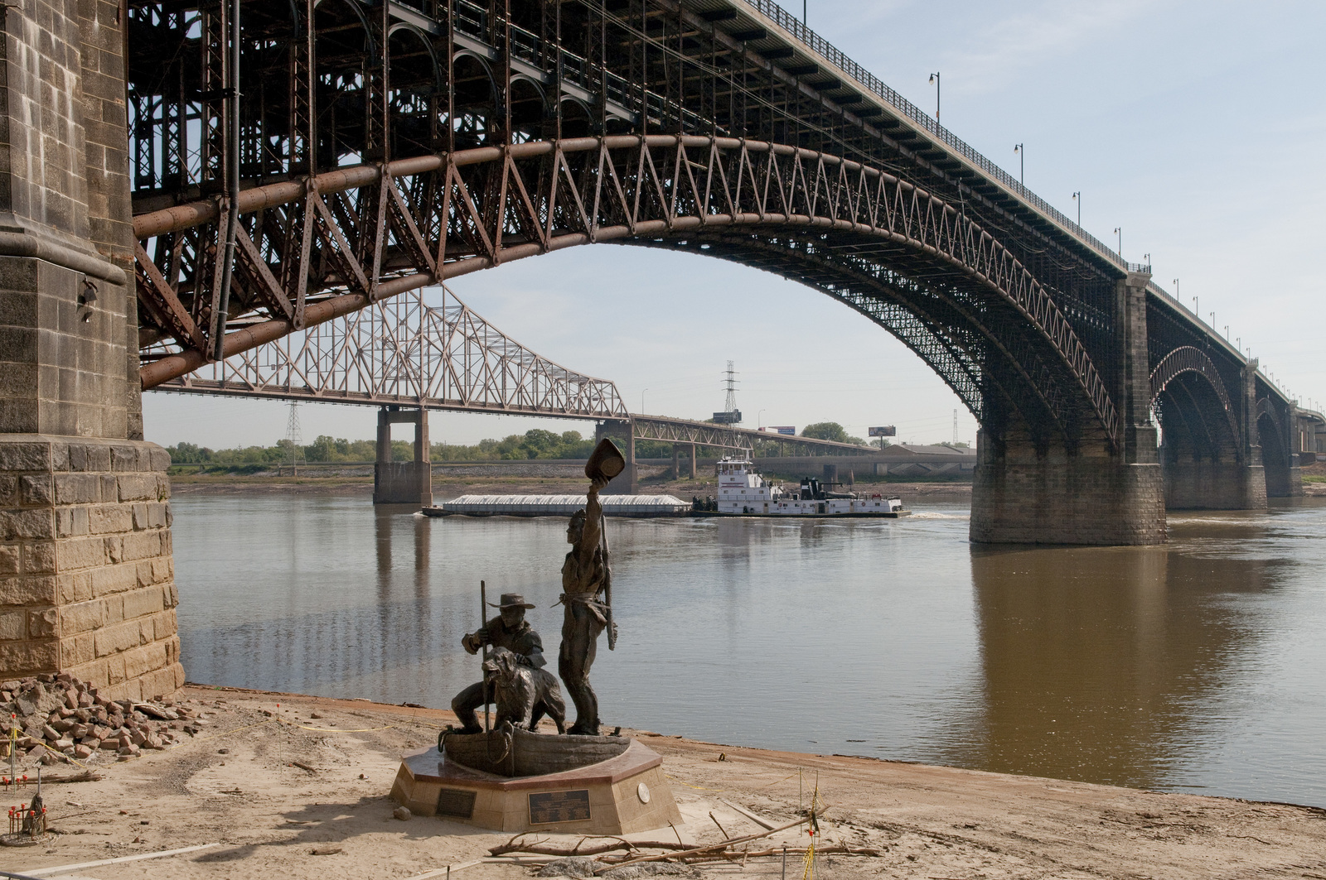
Credit Mark Godfrey, The Nature Conservancy

