IMPORTANT NOTE: This information is not to be released or distributed until 10 a.m. Central Time on October 14, 2015. A photo to accompany this story appears on page 2; please provide credit for this photo, which is listed below the image.

Recreation Receives a C Grade in the New
Mississippi River Watershed Report Card

The newly released Report Card produced by America’s Watershed Initiative (AWI) includes key information about recreation in the 31-state Mississippi Watershed. The AWI goal is that the Mississippi River Watershed, or America’s Watershed, provide world-class recreation opportunities that enrich the quality of life for people and related economies by maintaining and enhancing river, lake and wetland-associated recreation.

Communities and economies benefit from robust nature-based recreational activities in the Watershed. Every year in all seasons, millions of people fish, boat, hike, watch birds and visit cultural sites along the rivers. These activities support a multi-billion dollar recreational economy that is vital to the communities and businesses that provide related equipment and services. A major challenge in the future will be accommodating current and expanding opportunities for recreational uses as populations and demands continue to grow and change.

The Mississippi River Watershed received a C for recreation in the Report Card, as participation in most of the five sub-basins were at or below what has been seen in the recent past. Much more needs to be done to support current and emerging recreational opportunities through effective management of natural resources that support recreation. Additional information is also needed to evaluate some recreational uses.

The complete analysis for recreation in the Report Card—along with information about the other five goals for America’s Watershed—is available online at AmericasWatershed.org/ReportCard. The online information about recreation includes grades for each of the five sub-basins within the Mississippi River Watershed as well as what was measured and how it was evaluated.

###

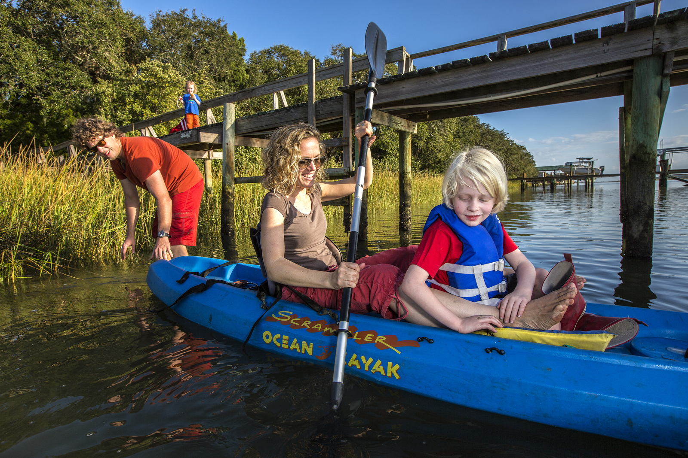
Credit Karine Aigner

