IMPORTANT NOTE: This information is not to be released or distributed until 10 a.m. Central Time on October 14, 2015. A photo to accompany this story appears on page 2; please provide credit for this photo, which is listed below the image.

Transportation Receives a D+ in the New
Mississippi River Watershed Report Card

The newly released Report Card produced by America’s Watershed Initiative (AWI) includes key information about river and marine transportation in the 31-state Mississippi Watershed. The AWI goal for the Mississippi River Watershed, or America’s Watershed, is that it serves as the nation’s most valuable river transportation corridor, providing safe, efficient and dependable commercial navigation to ensure a competitive advantage for the nation’s goods in global markets.

Commercial navigation is critical to the economic and social well-being of the United States and the world. Barge transport is a vital link in the transportation system that integrates rail, truck and international shipping systems to efficiently move goods and materials. It is a cost-effective method to provide the agricultural, energy and manufacturing sectors with materials and to transport products to national and global markets. The commercial navigation industry in the Mississippi River Watershed annually transports $54 billion dollars of agricultural products, representing 92% of the nation’s farm exports, including more than 60% of the U.S. grain products for global consumption. Sustaining and increasing this capacity through infrastructure maintenance, rehabilitation, updates and innovations is necessary in order to maintain a competitive economy that benefits an increasing number of people throughout the world.

The Mississippi River Watershed received a D- for transportation, with all basins reporting either D or F grades. Critical components for locks and dams are in relatively poor condition across the watershed, and a dangerous lack of funding for infrastructure maintenance means that multiple failures may be imminent. River transportation currently functions with some delays, but as these systems continue to deteriorate, significant failures could be expected, which would result in severe economic, public safety and water security problems.

The complete analysis for transportation in the Report Card—along with information about the other five goals for America’s Watershed—is available online at AmericasWatershed.org/ReportCard. The online information about transportation includes grades for each of the five sub-basins within the Mississippi River Watershed as well as what was measured and how it was evaluated.

###

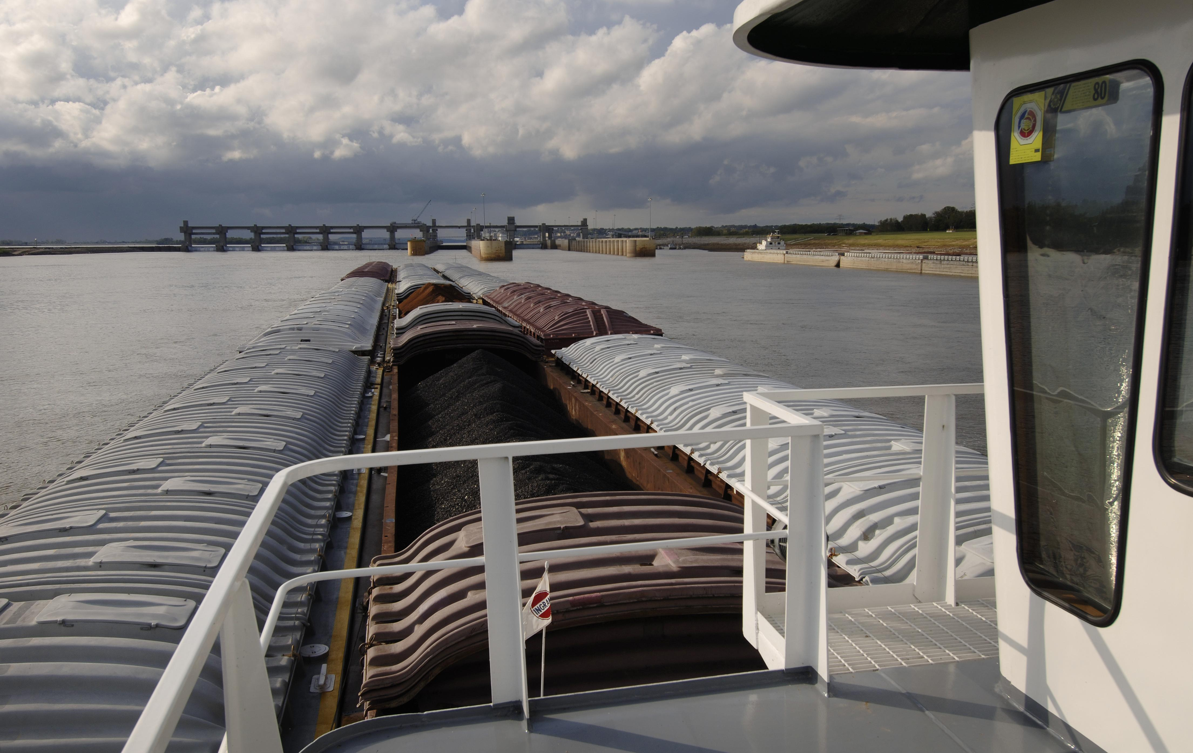
Credit Mark Godfrey, The Nature Conservancy

