IMPORTANT NOTE: This information is not to be released or distributed until 10 a.m. Central Time on October 14, 2015. A photo to accompany this story appears on page 2; please provide credit for this photo, which is listed below the image.

Upper Mississippi River Basins Receives a C in
New Mississippi River Watershed Report Card

The newly released Report Card produced by America’s Watershed Initiative (AWI) includes specific information and grades for the five main river basins that make up the 31-state Mississippi River Watershed, including the Upper Mississippi River Basin. In the Report Card, five goals for the Upper Mississippi River Basin are measured—water supply, flood control and risk reduction, the economy, ecosystems, recreation and transportation. Overall, the Upper Mississippi River Basin received an average grade of “C” for these six goals.

The Upper Mississippi River Basin is home to approximately 30 million people with three major cities and many smaller cities and towns. Forests and lakes in the northern headwaters and highly productive agricultural land to the south dominate the landscape. An extensive series of locks and dams regulate water levels on the Mississippi River south of Minneapolis and St. Paul, Minnesota, and on the Illinois River, providing navigation on the Mississippi River and to the Great Lakes through Chicago, Illinois. Popular recreation areas support extensive boating, swimming, hunting and fishing and include a 260-mile-long National Wildlife Refuge that includes parts of four states.

This basin had relatively few navigation delays, a high percentage of communities that have building elevation requirements as a non-structural flood protection measure, good quality streamside habitat, relatively high hunting and fishing license sales, and relatively high water availability compared to the national average. However, the condition and maintenance of the transportation infrastructure within the basin is poor, it has seen a substantial increase in population within floodplains (relative to the population change in the state), its water quality ranks poorly, and there is a high rate of wetlands loss.

The Upper Mississippi River Basin is located on the “wet side” of the 100th meridian, which marks a shift in rainfall pattern from the wetter eastern portions of the basins and the drier western portions. The Upper Mississippi therefore has relatively low water stress compared to other areas. Intense agricultural use and large population centers, including Chicago and Minneapolis, may contribute to poor water quality results and wetland losses.

The complete analysis for the Upper Mississippi River Basin in the Report Card—along with information about the other four basins that make up America’s Watershed—is available online at AmericasWatershed.org/ReportCard.

###

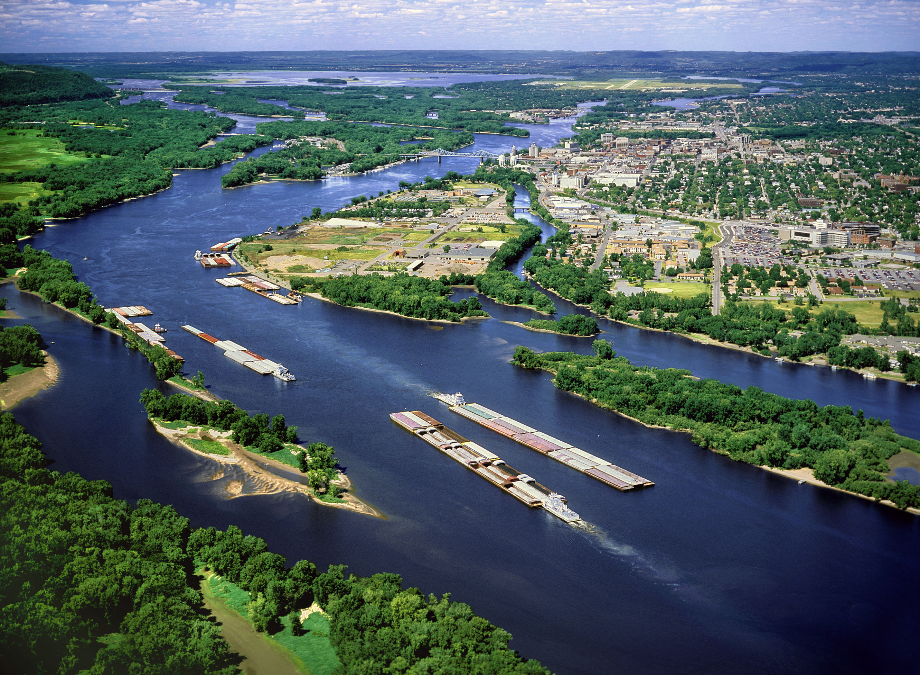

Credit Robert J. Hurt

