IMPORTANT NOTE: This information is not to be released or distributed until 10 a.m. Central Time on October 14, 2015. A photo to accompany this story appears on page 2; please provide credit for this photo, which is listed below the image.

Water Supply Receives C- Grade in the
New Mississippi River Watershed Report Card

The newly released Report Card produced by America’s Watershed Initiative (AWI) includes key information about the quality and abundance of water in the more than 250 heartlands rivers that flow in the 31-state Mississippi Watershed. The AWI goal for water is to maintain a supply of abundant clean water within the Mississippi River Watershed, or America’s Watershed.

People and communities throughout the watershed value clean and abundant water for many uses, including drinking water, supplies for farms and industry, recreation and the habitat it provides wildlife. The issues related to water quality and supply are complex, often controversial and vary among the different basins and regions of the watershed. Also, demand for surface and groundwater throughout the nation is rapidly growing as populations increase and more water is needed to grow crops and support industry.

These growing demands, combined with an aging water treatment and supply infrastructure, are putting unprecedented pressure on our water resources. In the future, there must be an integrated management approach that assures that our water supplies support society’s needs and opportunities in a balanced manner throughout the watershed.

The overall Mississippi Watershed received a grade of C- for water supply. All five river basins received D or C grades for this goal. The Watershed’s grade was a result of low grades it scored across the indicators used to measure water supply, including “water depletion” (grade B-) and “treatment violations” (grade D), which revealed that municipal systems are not performing well throughout the watershed.

The complete analysis for water supply in the Report Card—along with information about the other five goals for America’s Watershed—is available online at AmericasWatershed.org/ReportCard. The online information about water supply includes grades for each of the five sub-basins within the Mississippi River Watershed as well as what was measured and how it was evaluated.

###

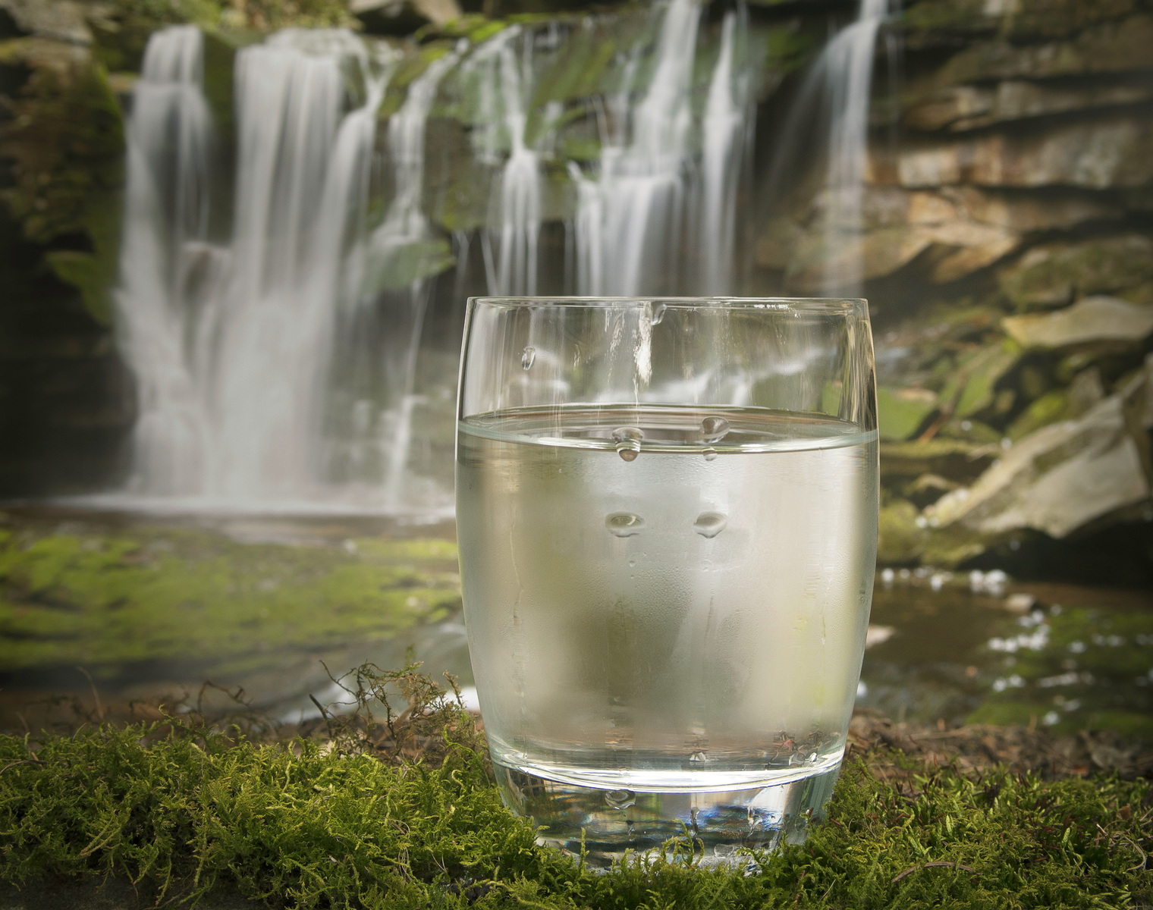
Credit The Nature Conservancy

