America’s Watershed Initiative Report Card
Basin-Specific Social Media Posts

After the release of America’s Watershed Report Card on Oct. 14, we’ve provided for your use the pre-written social media posts included in this toolkit to further promote the report in the days and weeks to come. Photos are included in this toolkit.

You can also help promote America’s Watershed Report Card by:
- Posting more social media messages about the report. In addition to this toolkit, we have provided another document with messaging related to specific report card goals.
- Following @AWInitiative and @Nature_org on Twitter and retweeting posts.
- Following The Nature Conservancy on Facebook and sharing content.

Use the Hashtag #RaiseTheGrade to help us track your social media

…….

The Upper Mississippi River Basin

High flood risk and concerns with transportation infrastructure were flagged in a new report card that measures the health of the Upper Mississippi River Basin. Overall, the Upper Mississippi received a “C” grade in the report, produced by America’s Watershed Initiative: http://bit.ly/1GoIHf5 #RaiseTheGrade

Photo: https://www.dropbox.com/sh/5jt1kjpm5ogp7lm/AAArLztOfNg7431hq7cL4Rapa?dl=0

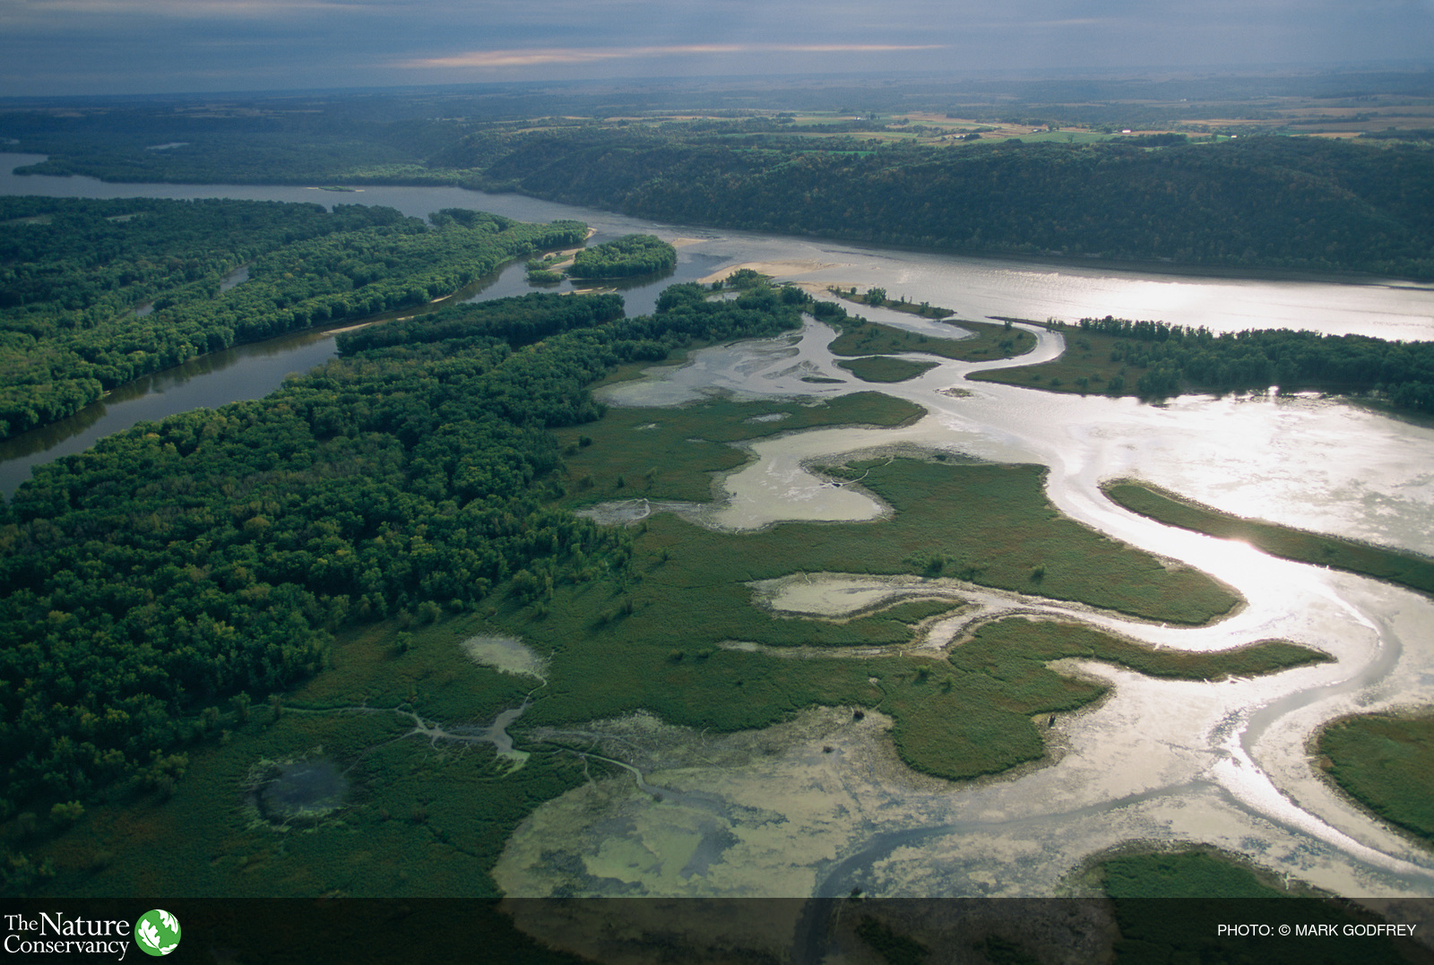

Ohio/Tennessee River Basin

The Ohio River and Tennessee River basins - home to 29 million people and covering parts of 14 states - earn a grade of “C” in a new report card produced by America’s Watershed Initiative. This report carefully measures the basin’s health in relation to growing economic and environmental demands: http://bit.ly/1GoIHf5
#RaiseTheGrade

Photos: https://www.dropbox.com/sh/wwz04i4z1np371c/AAAMVRI6aOhdgVyydB2nD6Tta?dl=0

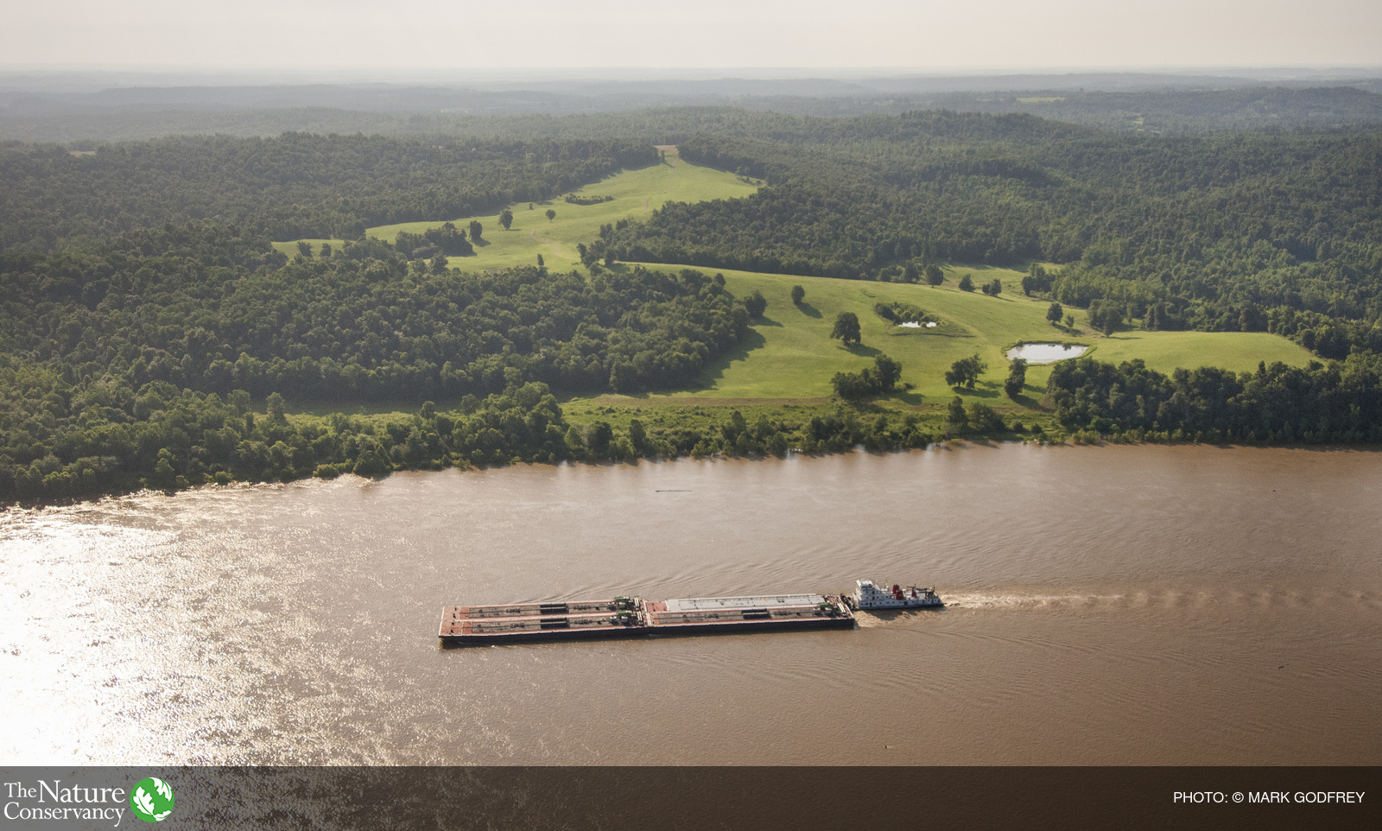

Lower Mississippi River Basin

The Lower Mississippi River basin received a “D+” grade in a new report card produced by the America’s Watershed Initiative to evaluate the health of the basin. The report measures flood risk, water supply and more; find out what drove this low overall score: http://bit.ly/1GoIHf5
#RaiseTheGrade

Photo: https://www.dropbox.com/sh/km4beniikglcsvd/AACCAif4azE6ss_IyuWtpmwBa?dl=0

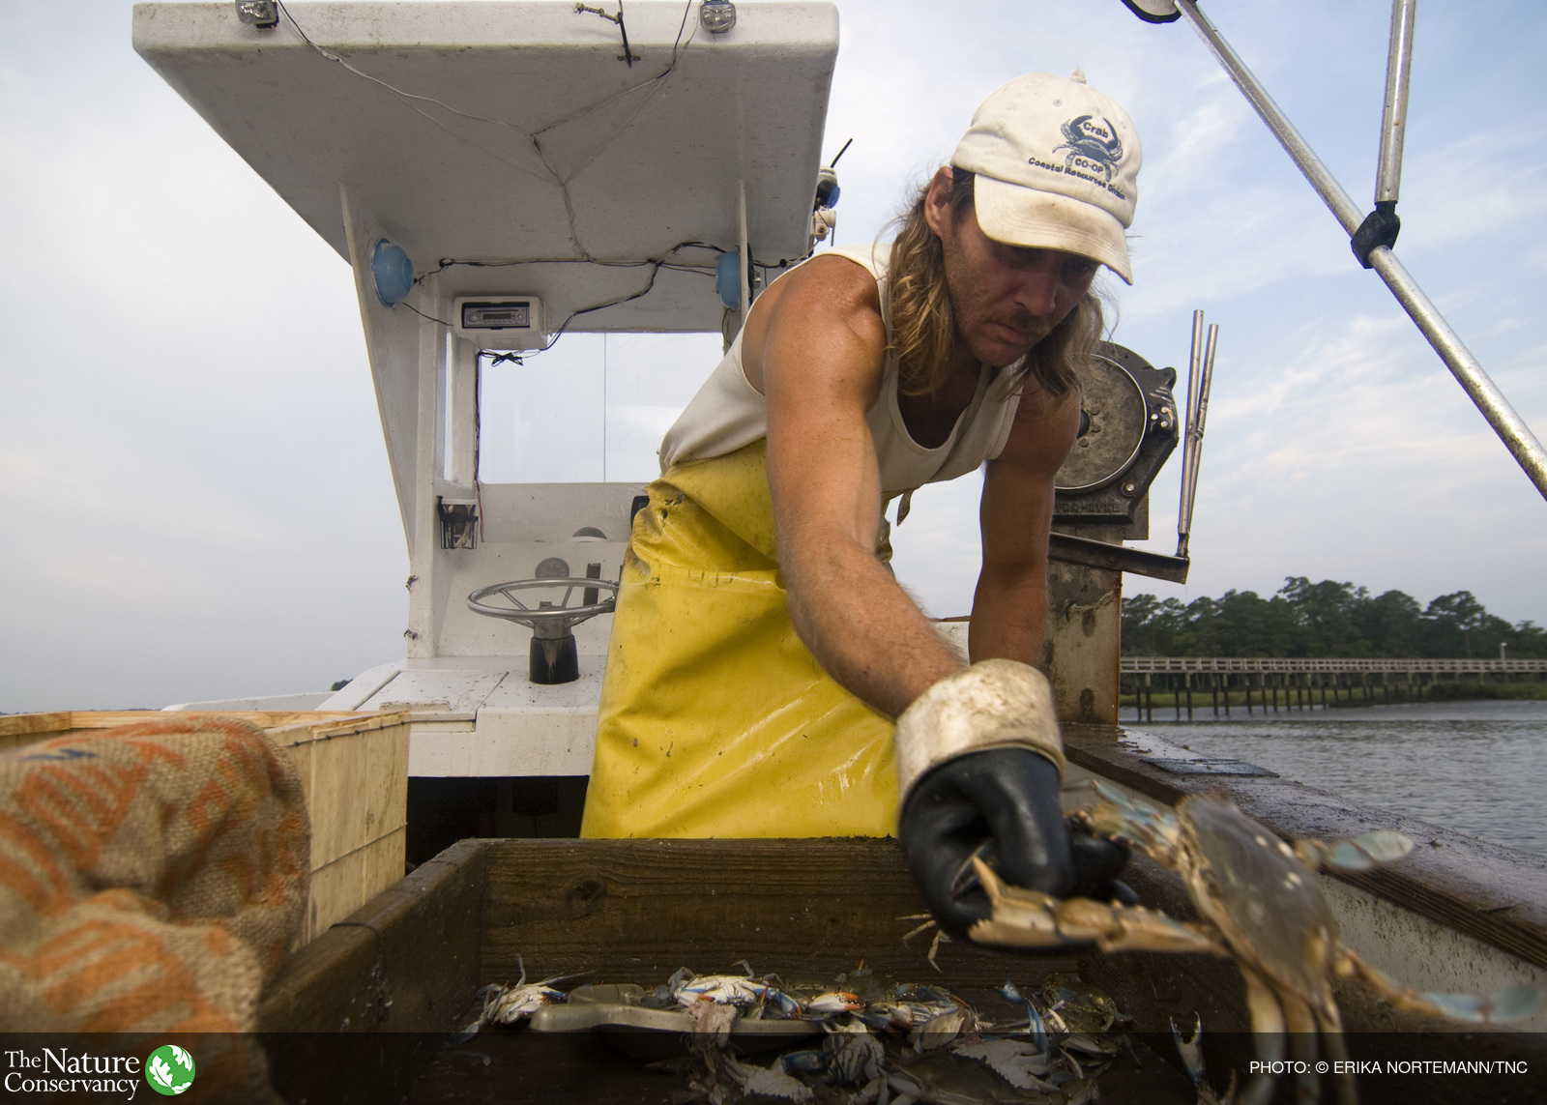

The Arkansas/Red River Basin

The Arkansas River and Red River basins, which represent the driest portions of the Mississippi River watershed, earn a grade of “C-” in a new report measuring overall health of the watershed. The region received high marks for water supply but scored poorly on flood control. The report points to a large number of uninspected levees, a growing numbers of people at risk from living in the floodplain, and low community preparedness: http://bit.ly/1GoIHf5 #RaiseTheGrade

Photo:
https://www.dropbox.com/sh/2w3msh5kkwezzzq/AAAG6wQfPR3jm0ZS0bhEPycNa?dl=0

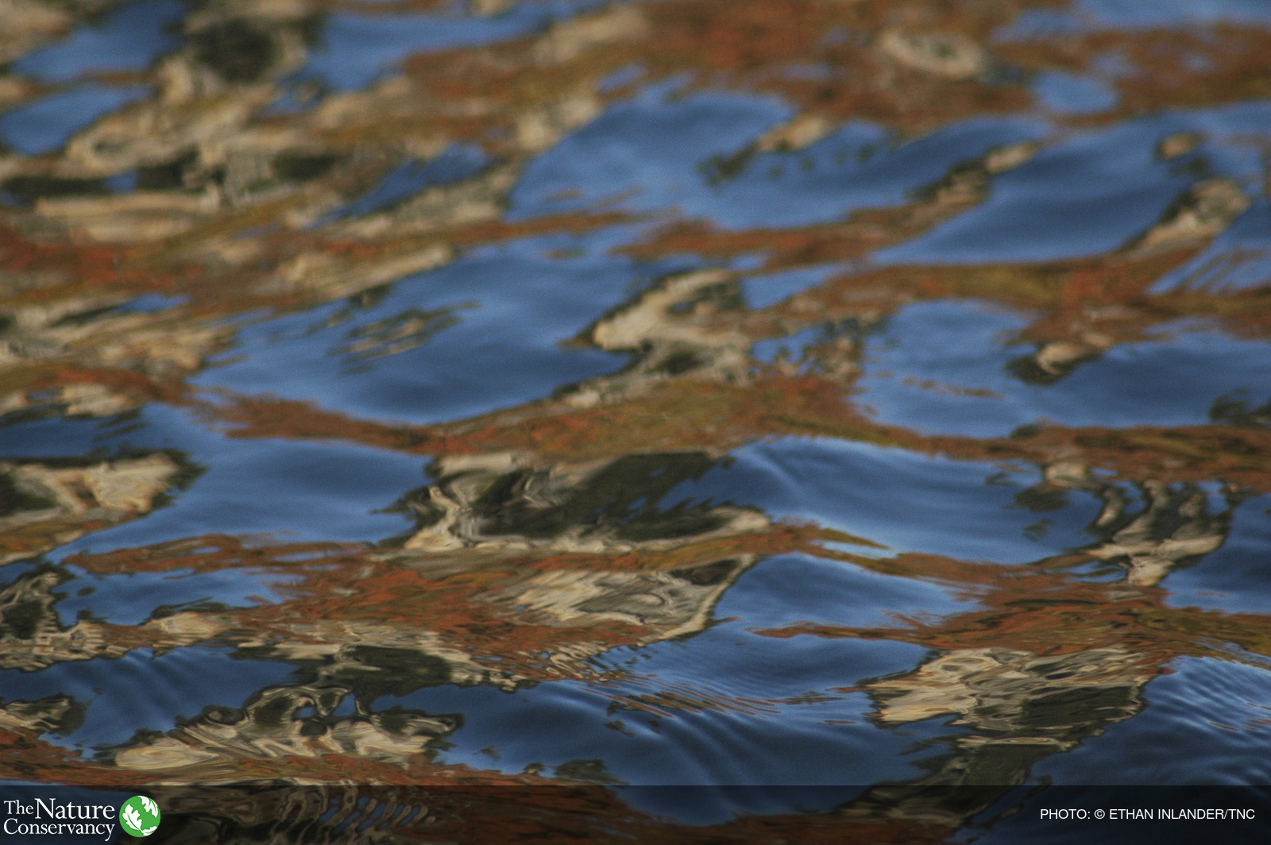

Missouri River Basin

The Missouri River basin, the longest tributary and largest basin in the Mississippi watershed, earns a grade of “C” in a new report card produced by America’s Watershed Initiative. The report measures overall health of the basin in response to growing economic and environmental demands. Find out how we can #RaiseTheGrade: http://bit.ly/1GoIHf5

Photo:
https://www.dropbox.com/s/jgdf5twrfc46xs7/tnc_54309437_preview_cropped.jpg?dl=0

