America’s Watershed Initiative Report Card
Social media messaging—Goal-specific posts

After the release of America’s Watershed Report Card on Oct. 14, we’ve provided for your use the pre-written social media posts included in this toolkit to further promote the report in the days and weeks to come. Photos are included in this toolkit.

You can also help promote America’s Watershed Report Card by:
- Posting more social media messages about the report. In addition to this toolkit, we have provided another document with messaging related to specific report card goals.
- Following @AWInitiative and @Nature_org on Twitter and retweeting posts.
- Following The Nature Conservancy on Facebook and sharing content.

Use the Hashtag #RaiseTheGrade to help us track your social media

…….

Seven Goal-Themed Posts for Social Media

1. Transportation

Facebook:
Planes, trains and automobiles – and the mighty Mississippi. Agricultural products worth $54 billion are transported annually through waterways in the Mississippi River Basin, representing 92% of the nation’s farm exports. But locks and dams are in poor condition across the watershed, posing a threat to this important transportation hub. Find out how we can #RaiseTheGrade in a new report from America’s Watershed Initiative: http://bit.ly/1GoIHf5

Twitter:
Report from @AWInitiative flags transportation concerns in Mississippi Basin: http://bit.ly/1GoIHf5 #RaiseTheGrade

Locks & dams in poor condition across Mississippi Basin, according to @AWInitiative: http://bit.ly/1GoIHf5 #RaiseTheGrade

Image: https://www.dropbox.com/sh/zlynku0tqvl6jpb/AADdiWkOHtTxEymQ3JkbTz93a?dl=0

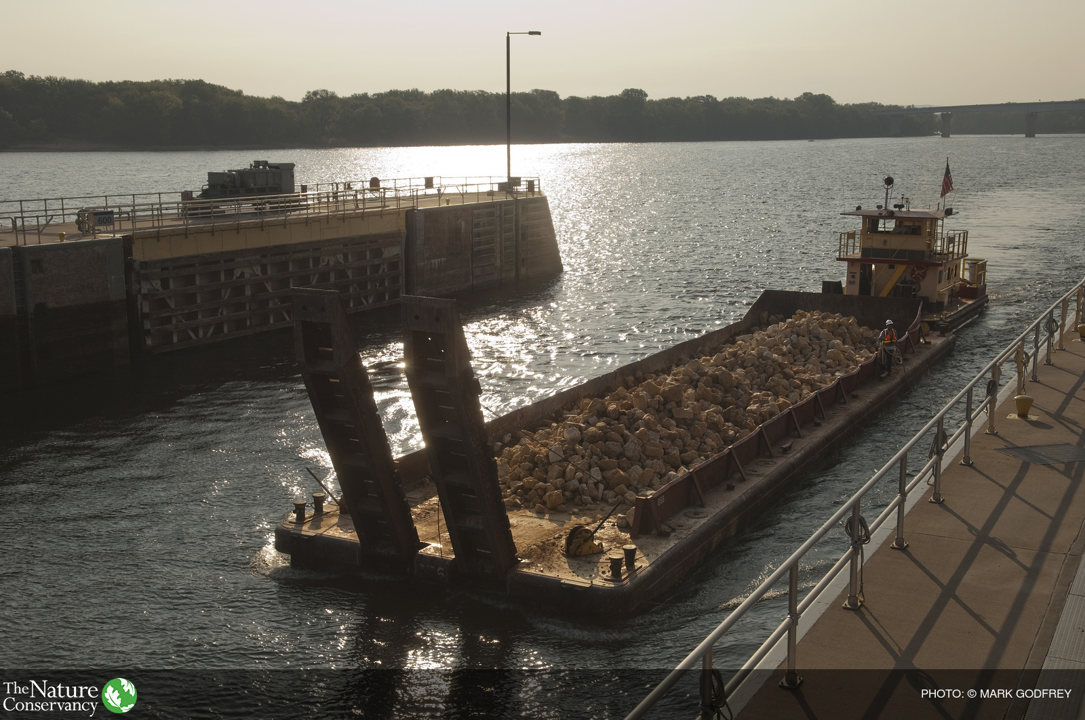

2. Economy

Facebook:
From the bread on your table to the shirt on your back, more than half of all goods and services in America are produced with water flowing through the Mississippi River Basin. Can the basin keep up? A new report card from America’s Watershed Initiative measures the health of the watershed: http://bit.ly/1GoIHf5 #RaiseTheGrade

Twitter:

Half of US goods & services are produced with water flowing through Mississippi watershed: http://bit.ly/1GoIHf5 #RaiseTheGrade

Photo: https://www.dropbox.com/sh/gjkhk9c8q3qqepj/AAAVKuKM4CSJp3eATqI2Cqp9a?dl=0

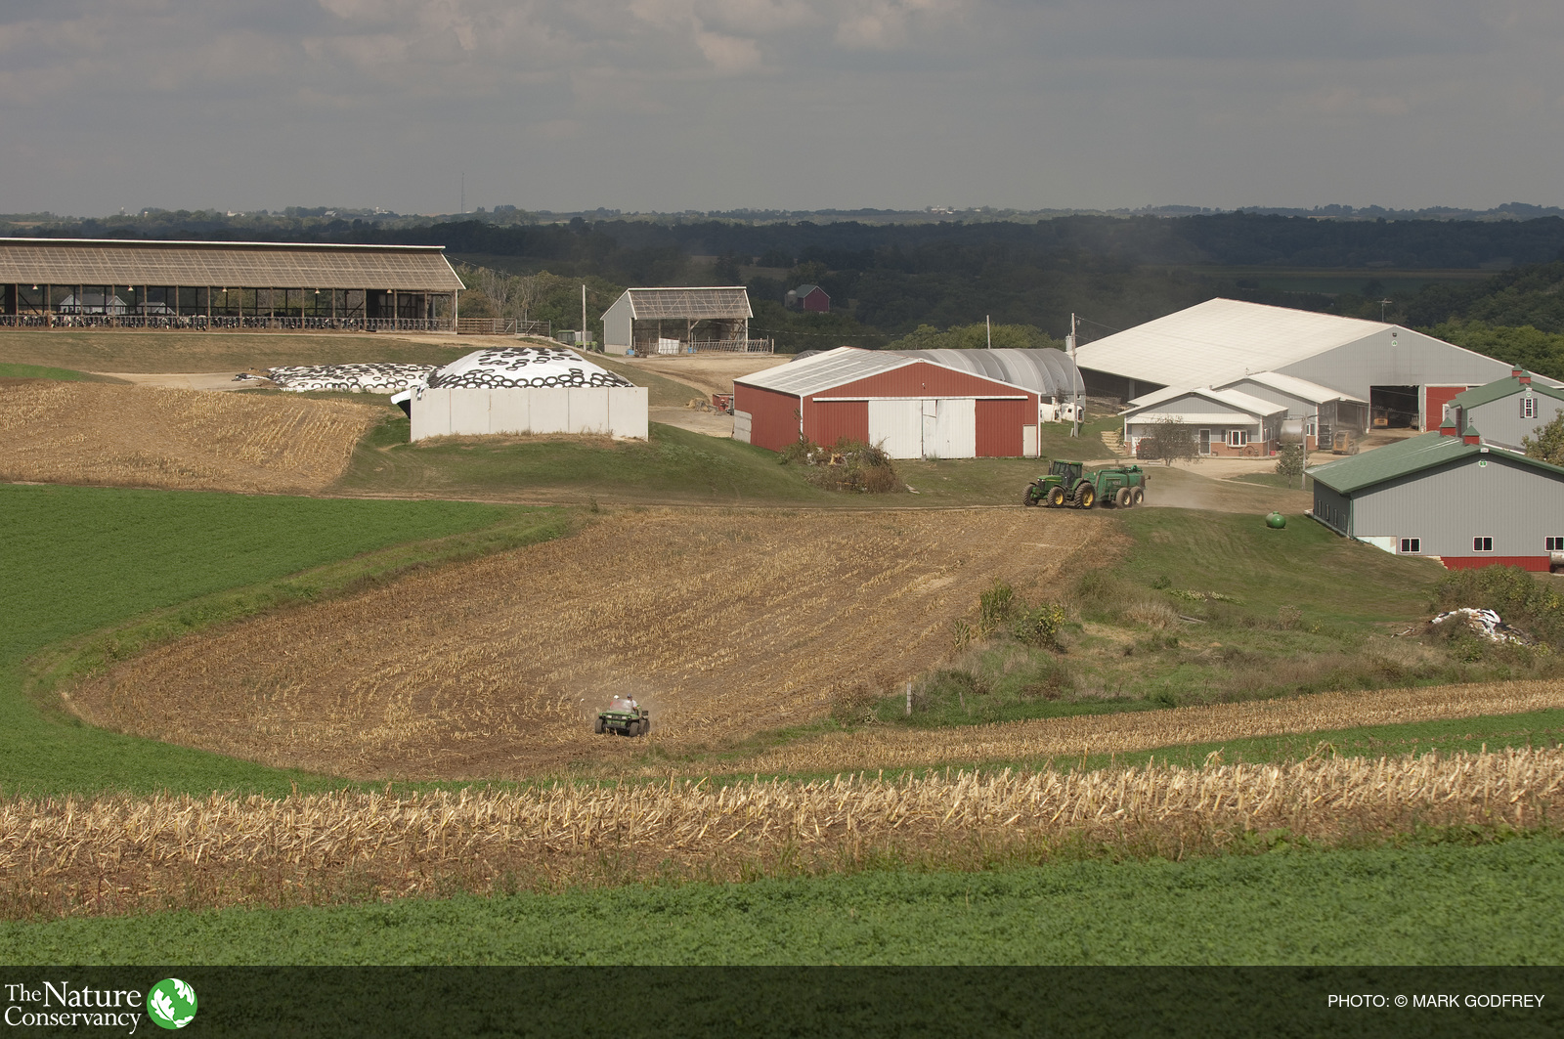

3. Recreation

Facebook:
“Like” this post if you’ve ever hiked, biked, camped, boated, fished or swum in the Mississippi River watershed. A new report card produced by industry experts gave the watershed a “C” rating for recreation, flagging growing demands on river resources: http://bit.ly/1GoIHf5 #RaiseTheGrade

Twitter:
Mississippi River Watershed gets “C” grade for recreation: http://bit.ly/1GoIHf5 #RaiseTheGrade

Photo: https://www.dropbox.com/sh/rfwa30w1kcndfbd/AABfkTTzpyw-zMxOPK1JWguia?dl=0

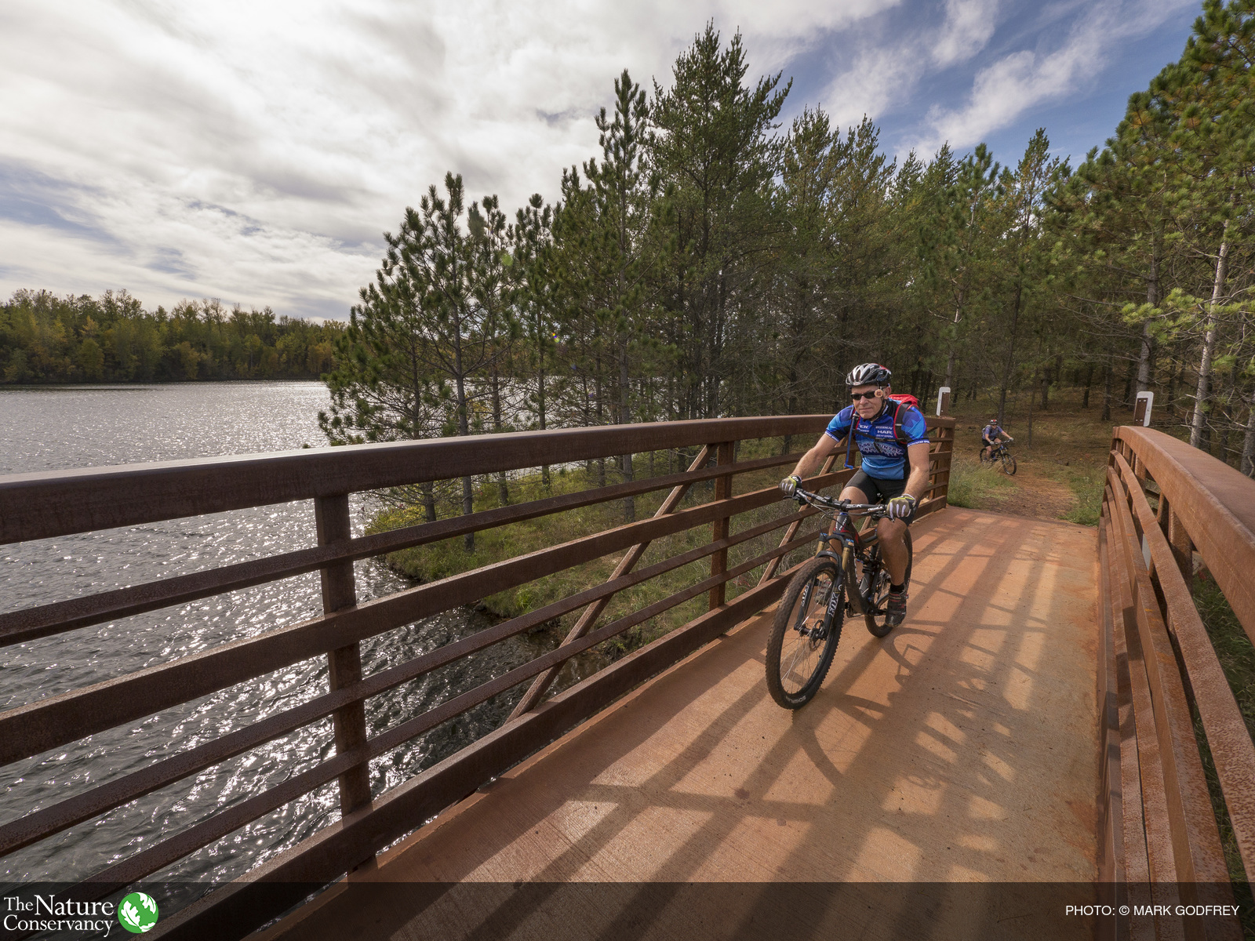

4. Ecosystems

Facebook:
A new industry report card gives the Mississippi River Basin a “C” grade for overall ecosystem health. A key contributor to the rating: Runoff of excess nutrients threatening both the watershed and the Gulf of Mexico, where it fuels the hypoxic “dead zone”: http://bit.ly/1GoIHf5 #RaisetheGrade

Twitter:
Runoff of nutrients threatens Gulf & Mississippi Basin. Let’s #RaiseTheGrade: http://bit.ly/1GoIHf5

Photo: https://www.dropbox.com/sh/5tfm081a0zyrpoy/AADFb6oI8I782udB5ky8eIywa?dl=0

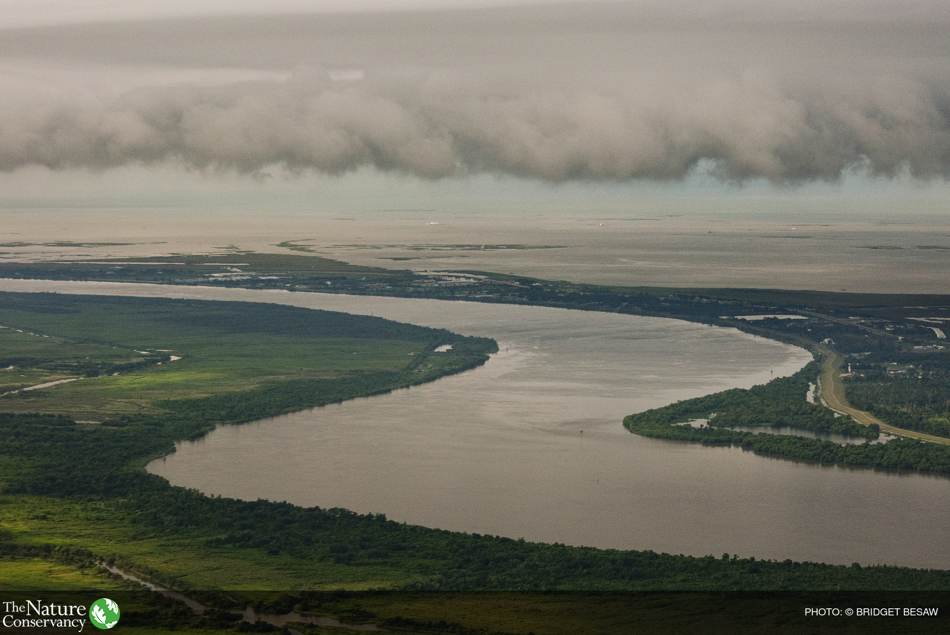

5. Flood Control

Facebook:

Major flood risks were flagged in a new report card that measures flood control and risk reduction across the Mississippi Basin from the headwaters to the Gulf. Severe flood risks were highest in the eastern portion of the watershed and along the Lower Mississippi: http://bit.ly/1GoIHf5 #RaisetheGrade

Twitter:
Major flood risks flagged in @AWInitiative report on Mississippi Watershed: http://bit.ly/1GoIHf5 #RaiseTheGrade

Photo: https://www.dropbox.com/sh/1cjr66t6fphppx1/AAAAG2uLSoNb06TlpnGJ210Ra?dl=0

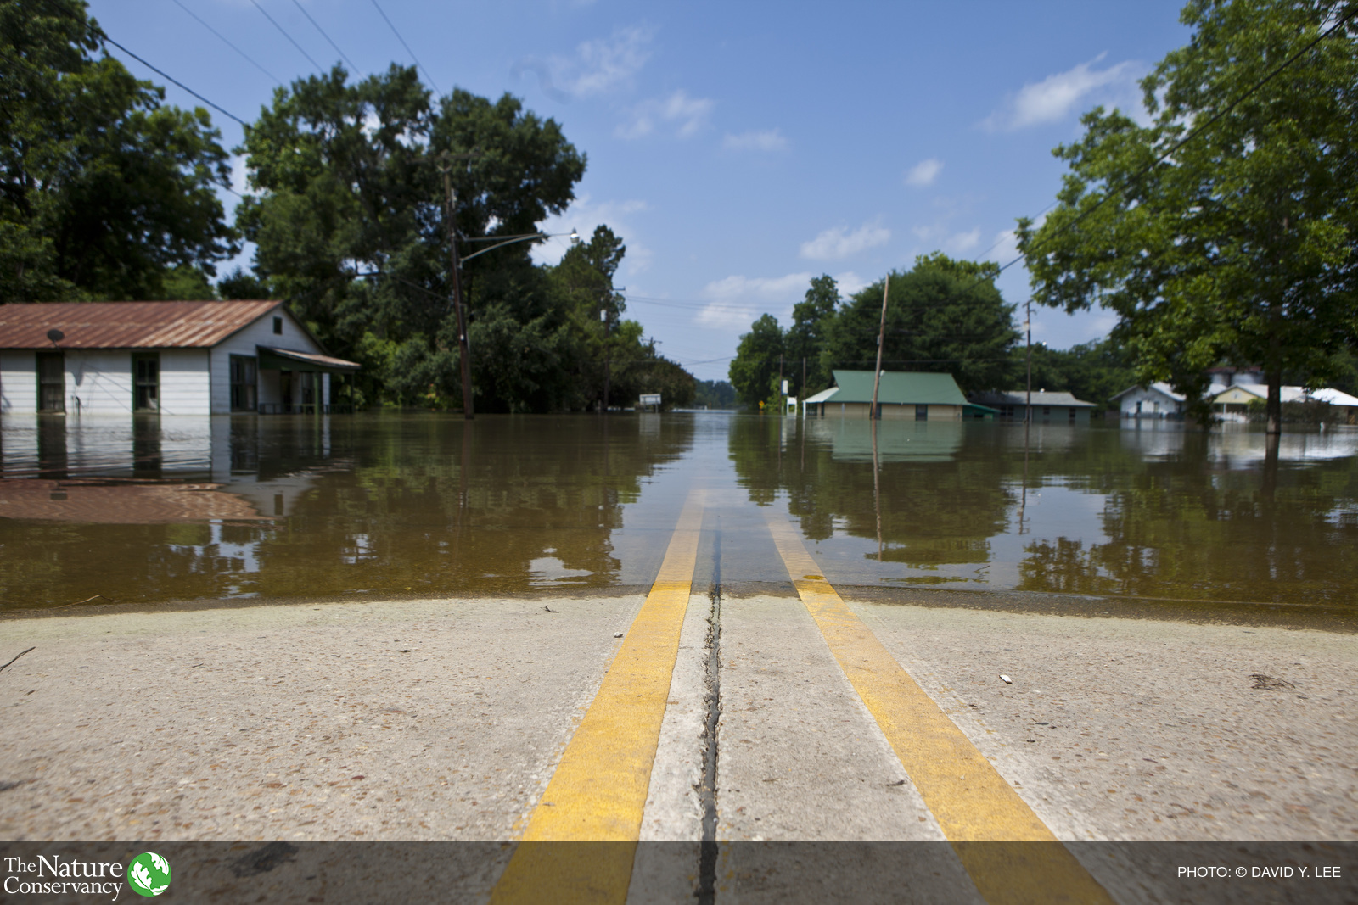

6. Water

The Mississippi Watershed received a grade of “C-“ for water supply in a new report card measuring the overall health of the basin. The watershed provides clean drinking water for millions and water for farms and ranches. Now, leaders are looking for opportunities to ensure a quality water supply amid growing pressures: http://bit.ly/1GoIHf5 #RaiseTheGrade

Twitter:
Mississippi Watershed received a grade of “C-“ for water supply in new @AWInitiative report: http://bit.ly/1GoIHf5 #RaisetheGrade

Photo: https://www.dropbox.com/sh/1bl17id9wnzjmq9/AAAjPn81oNxyMePHdJoJBvy-a?dl=0

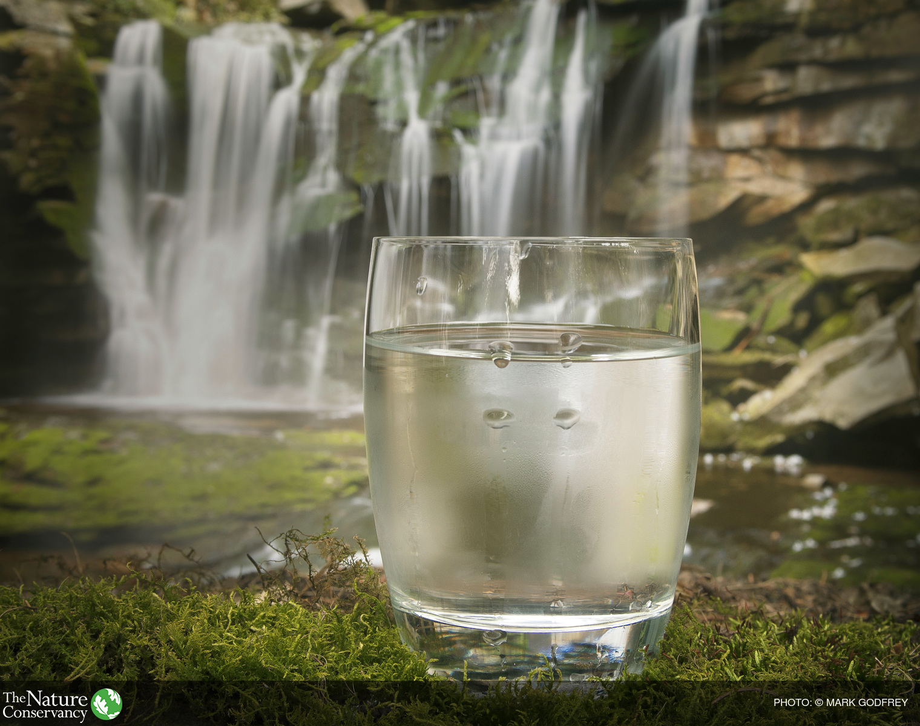

7. Region-based post

Facebook:

The Mississippi River Basin received a “D+” in a first-ever report card measuring the health of the basin, which spans 31 states. But how did your specific region score?
The new report breaks down challenges and ratings in five river basins, including the Upper and Lower Mississippi Basins, Ohio & Tennessee River Basins, The Arkansas and Red River Basins and the Missouri River Basin.
Explore local results: http://bit.ly/1GoIHf5 #RaiseTheGrade

Twitter:

5 river basins rated in new Mississippi watershed report card - find yours: http://bit.ly/1GoIHf5 #RaiseTheGrade

Photo: https://www.dropbox.com/sh/id7jqazmshix7ap/AAArZDrE4P63-qwhmpeO-w3Xa?dl=0

